This Service Agreement Statement has been developed for the purpose of ensuring that the participant and/or their nominee and/or care network are aware of their responsibilities, and that of SWDS. The Service Agreement is used as a reference throughout the supports detailed on all current Service Schedules.

The Service Agreement is broken down by color and information type

Service Schedule – Page 1

Responsibilities of Service Provider – South West Disability Services – Page 2

Responsibilities of Participant and Nominees- Page 2

Changes to Service – Pages 3 and 4

Payments and Costs – Page 5

Complaints and Feedback – Page 6

Service Schedule

A Service Schedule details the support that will be delivered to a participant through the use of the participant’s NDIS plan or privately paid.
The Service Schedule will detail costs, programs/type of engagement, and costs through NDIS or the participant.
This will be updated and amended as required and will align with the most current terms as listed in the most recent version of this Service Agreement Statement.

Picture 1- Picture 2-
Example of Service Schedule front page Example of Service Schedule term
breakdown
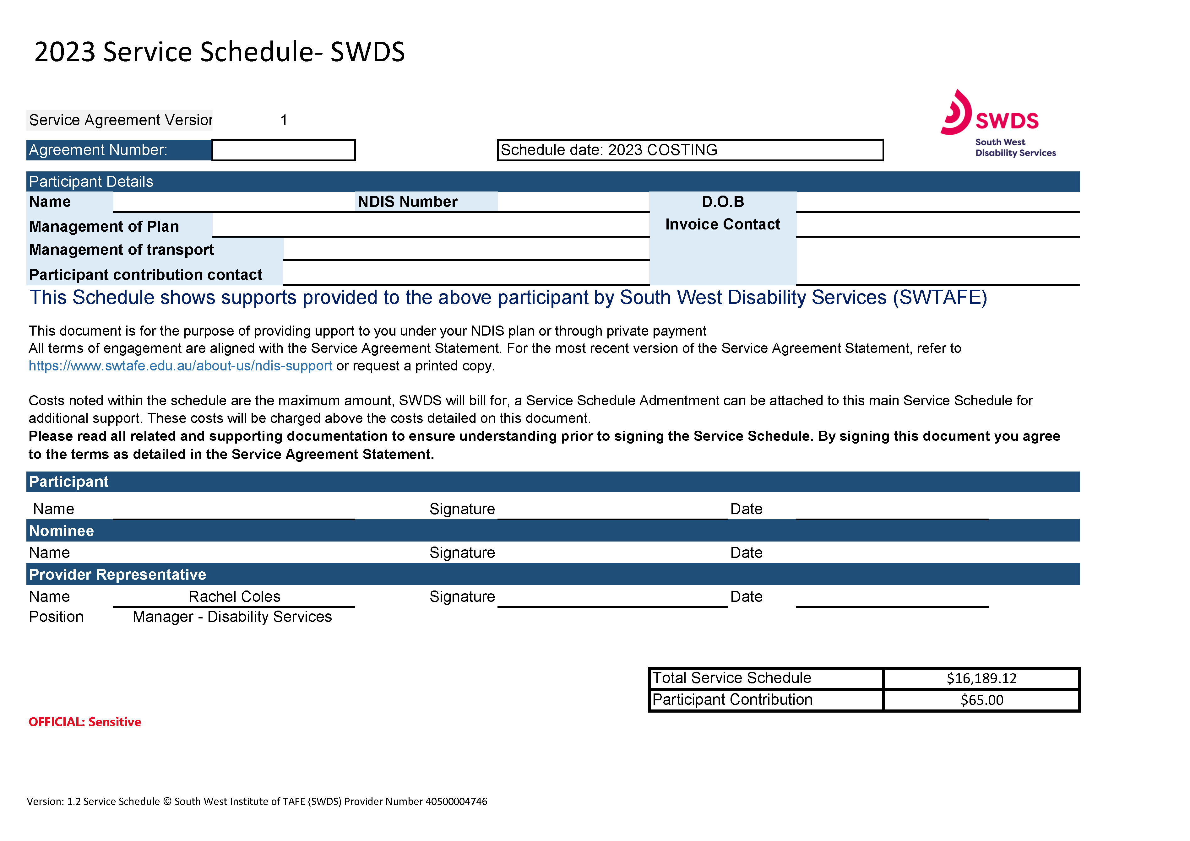
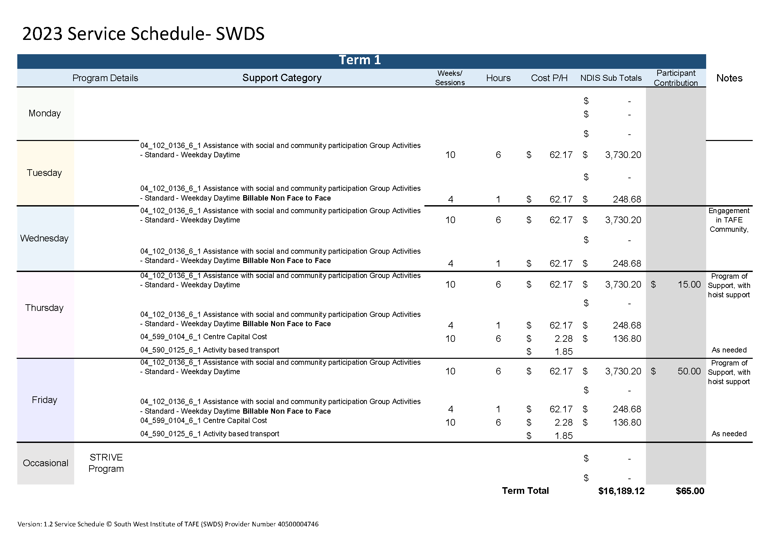

Responsibilities of Service Provider – South West Disability Services
- To take all reasonable steps to deliver the support that is detailed in the Service Schedule for the nominated period, as agreed upon by the participant and/or their nominee and South West Disability Service.
- To provide the participant and/or their nominee an appropriate amount of lead time when changes of support occur, including cancellation of shift, and changes to shift times (where possible 12 hours minimum).
- Promote involvement by the participant and/or their nominee in decision-making around support.
- To develop and maintain accurate records relating to the support provided to the participant.
- Issue invoices and statements in a timely and efficient manner.
- Collect, maintain and store personal information in accordance with South West TAFE’s Privacy Policies.
- Communicate openly and honestly.
- Listen to feedback provided to South West Disability Services and resolve any disputes and/or issues in a timely and effective manner.
- Provide support that remains at the center of the participant receiving care
- To work with care, compassion, and professionalism while being guided by the participant receiving support

Responsibilities of Participant and Nominees

- To contact South West Disability Services if the participant and/or their nominee have any concerns around their current Service Schedule delivery.
- To provide South West Disability Services with 48hrs notice in the event of any variation to service delivery.
- Where a participant engages in a Program of Support model, the participant and/or nominee will provide South West Disability Services with 2 weeks’ notice in the event of withdrawal from the program. Engagement during the two-week notice period is encouraged
- •To work with South West Disability Services in a manner that will ensure that the individual requirements are met and the service delivery accurately reflects the participant’s goals and funding.
- •To recognise that the Service Schedule will reflect the support that is provided by South West Disability Services, and is aligned to this Service Agreement. The Service Agreement will dtail the terms, conditions and requirements.
- •To notify South West Disability Services if the an NDIS plan is suspended, reviewed or replaced by the NDIS or if the participant ceases being a participant of the NDIS.
- •Notify and disclose any behavioral or potentially high-risk concerns/ criminal convictions.
- •To abide by South West TAFE and South West Disability Services policies, procedures and rules as applicable. (these can be found on the SWTAFE website)

Changes to Service
Cancellation or ‘No Show

Where a participant and/or their nominee wish to cancel a standard support listed in the Service Schedule, the participant or nominee is required to contact South West Disability Services via telephone on (03) 55648720, 48hrs prior to the support being provided. If no notice is given prior to a cancellation or no show, South West Disability Service is able to recover 100% of the support cost as per the NDIA price guide. Ongoing cancellation or no show by the participant will result in NDIS being notified and may trigger a NDIS plan review.
If the participant is engaging in supports as part of a program of supports, participant will be invoiced for full attendance of the program, regardless of absence from a session.

Changes to supports
All changes to support are required to be processed by the NDIS Program Officers, NDIS Officer, or Manager of Disability Support at the Warrnambool Office.
(03) 5564 8720
disability.support@swtafe.edu.au
Disability Support Workers are not authorised to make any adjustments and/or changes to a Service Schedule.
An amendment will be made to reflect the change on the participant’s Service Schedule where the funding or significant change is required.

Program of Support - Group
NDIS programs (up to 12 weeks duration) are classified as a program of support. As such, the cancellation period for a session does not apply and you will be invoiced for the entirety of the program. If you wish to withdraw from the program of support, 2 weeks’ notice is required. SWDS will cover 10km per NDIS program for activity-based transport. Additional km’s will be apportioned amongst participants for group transport and invoiced accordingly.

Billable non-face-to-face hours
Non-face to face hours are automatically calculated per program, per individual to incorporate goal attainment and progress reporting at key points. Additional billable non face to face hours are calculated individually through discussion or request as needed and will be listed on the Service Schedule as ‘as required’. Where additional reporting is requested, this may be negotiated through engagement.

Early Arrival/Late Leaving
Where a participant arrives or leaves outside of the agreed-upon support hours listed within the Service Schedule, SWDS will continue to provide you with support, unless agreed upon through dignity of risk.

This support will be billed in 15-minute increments. This includes:
- Arriving before your agreed start time.
- Leaving later than your agreed finish time.
South West Disability Services will take all measures to ensure the health and well-being of a participant is the priority of the service. Contact will be made with the participant and/or their nominee where early arrival is noted on a regular basis, no-show or late picks ups.

Termination of agreement and services
Should either the participant and/or their nominee or South West Disability Service or South West TAFE wish to end this Agreement and Service Schedule, notice of 2 weeks is required. In the event of a serious breach of this agreement, the agreement and Schedule will be terminated immediately. Any moneys held in a service booking will be released upon confirmation of termination. Where the Service Schedule date expires, South West Disability Service may cease providing support, if support continues in faith (at the discretion of SWDS) the participant and or nominee agree to be liable for any support associated costs.

Payments and Costs
Distribution of invoices
All invoices will be distributed by South West TAFE on a regular basis following the delivery of service. Where a participant utilises a South West TAFE vehicle, each KM will be charged at .85c for car and $1.85 for bus- accessable (plus GST where appropriate), where there is a group use of the vehicle this cost will be shared.

This will be categorised as either;
Activity Based Transport – GST exempt
or
Transport – plus GST

Invoices will be distributed as per Service Schedule details and NDIS plan and will be payable within thirty (30) days of the date of invoice, in the event that invoices cannot be paid by the due date, the participant and or nominee is required to contact South West Disability Services on (03) 5564 8720 to discuss and negotiate alternative ways of payment.

Amendments to pricing
Support prices are reflective of the most current NDIA Price Guide. Price increase will be automatically amended upon release of new NDIA Price guide. Updates that occur outside of the annual price increase will be provided in SWDS newsletter or via independent communication

GST
NDIS items are GST exempt, as stated within the GST Act 1999 Section 38. Where the participant is required to pay for consumables or services outside their current NDIS plan GST may be applicable. A supply of supports under this Service Agreement is a supply of one or more reasonable and necessary supports specified in the statement of supports included, under subsection 33(2) of the National Disability Insurance Scheme Act 2013 (NDIS Act), in the Participant’s NDIS Plan currently in effect under section 37 of the NDIS Act.

Complaints and Feedback
SWDS empower all participant and/or their nominee to give feedback. This may be a compliment, complaint or improvement.

This can be done by:
Phone: (03) 5564 8720
Email: disability.support@swtafe.edu.au
Person: Timor Street - Warrnambool Campus I Building

Where a participant feels that their concern requires further assistance that is not SWDS, they may contact;
the NDIS Quality and Safeguarding Commission

Phone: 1800 035 544

or
submit a complaint contact form online at www.ndiscommission.gov.au

All participants and their nominees have a right to an advocate, a list of advocates can be supplied upon request and is included in the participant handbook upon engagement in support.

